*Florida International University*

*School of Computing and Information Sciences*

CIS 4911 - Senior Capstone Project

Software Engineering Focus

Feature Document

User Story # 554

**Team Member:**

Garrett Lemieux

**Product Owner(s)**:

Francisco Ortega

**Mentor(s)**:

Francisco Ortega

**Instructor**: Masoud Sadjadi

**User Story-**Save a File

* As a User I would like to save to a file so I can reload it at a later time.
* Acceptance Criteria:
  + User must be able to save a file.
  + Save multiple types of files.
  + All data must be in the file correctly saved.

**Use Case: User Saves a File**

* Details:
* Actor: User
  + Pre-conditions:
  + TouchPoint app is running.
  + User created a new image on a canvas to save.
* Description:
  + Use case begins when user needs to save work done on canvas.
  + User can save image on canvas in three different files by pressing keyboard. P = .png , J = .jpg T = .tif
  + When User select decides on file type and presses a key the canvas is saved and file is created in home directory.
* Post-conditions:
  + User can find specified saved file in home directory and can then open file to observe saved canvas.
* Decision Support:
  + Frequency: High, User will be saving work during development and also will need to save the completed image.
  + Criticality: Medium, The save function is critical for playback function which will be implemented in later sprints.
  + Risk: Low, Needed to read about cinders Image input output library.
* Usability:
  + Save function can be used for any device implemented in the paint program.
* Reliability:
  + High
* Performance
  + Performance: High
  + Failure: Low
* Supportability
  + All device in touchPoint app
* Modification History:
  + Owner: Garrett Lemieux
  + Initiation Date 02/11/2016
  + Date last Modified: 05/3/2016

**Use Case Diagram**

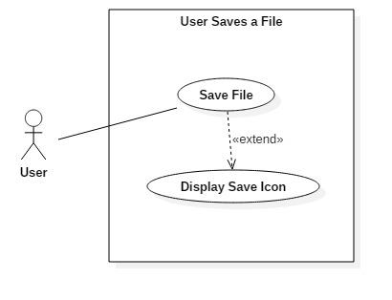

**Sequence Diagram**

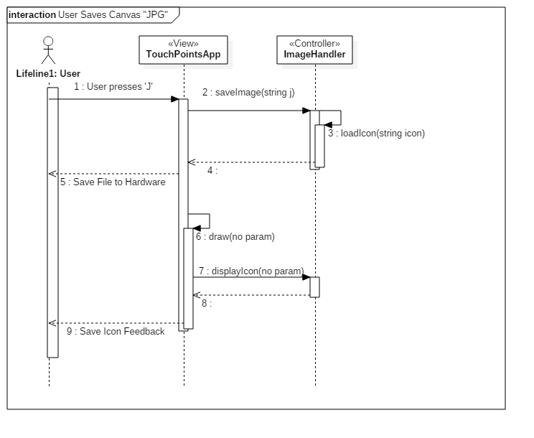

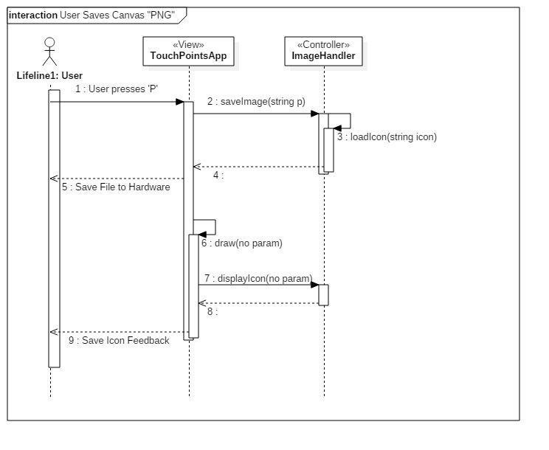

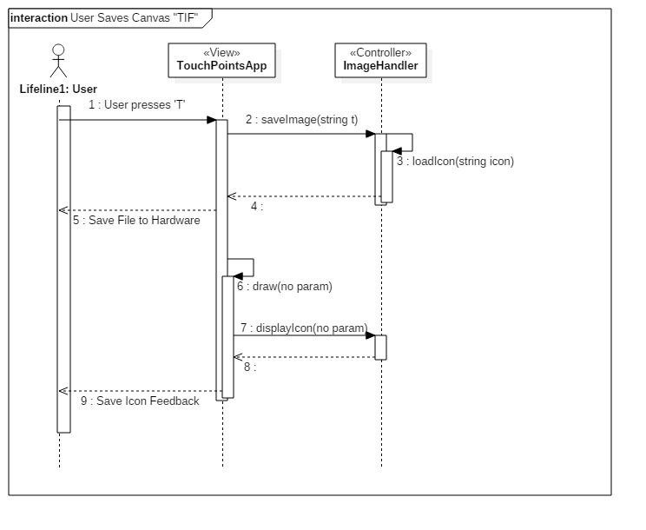

**Class Diagram**

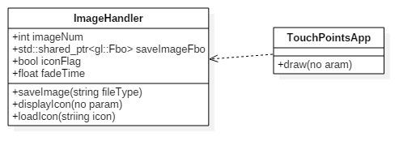

**Unit Test**

* Sunny Day Test:
  + Test Case  - User Presses ‘J’ Key
    - Test Purpose: To determine if user can save a .jpg file that has the current canvas saved to it.
    - Test Procedure: User plugs in Acer Multi touch device and starts program. He or she then draws a picture on canvas. User presses ‘J’ button once.
    - Expected Results: User should see feedback in the form of a save icon that fades out after specified amount of time. The user should also be able to find a .jpg file with the current canvas saved to it.
  + Test Case  - User Presses ‘T’ Key
    - Test Purpose: To determine if user can save a .tif file that has the current canvas saved to it.
    - Test Procedure: User plugs in Acer Multi touch device and starts program. He or she then draws a picture on canvas. User presses ‘T’ button once.
    - Expected Results: User should see feedback in the form of a save icon that fades out after specified amount of time. The user should also be able to find a .tif file with the current canvas saved to it.
  + Test Case  - User Presses ‘P’ Key
    - Test Purpose: To determine if user can save a .png file that has the current canvas saved to it.
    - Test Procedure: User plugs in Acer Multi touch device and starts program. He or she then draws a picture on canvas. User presses ‘P’ button once.
    - Expected Results: User should see feedback in the form of a save icon that fades out after specified amount of time. The user should also be able to find a .png file with the current canvas saved to it.
* Rainy Day Test:
  + N/A

**Integration Testing**

* The ability to us save function will be available for all devices implemented in the TouchPoints App.
* After implementing the save file feature the program stills runs correctly.

**User Guide**

* N/a – These features are no longer available to user. Instead a transparency save canvas feature was implemented.